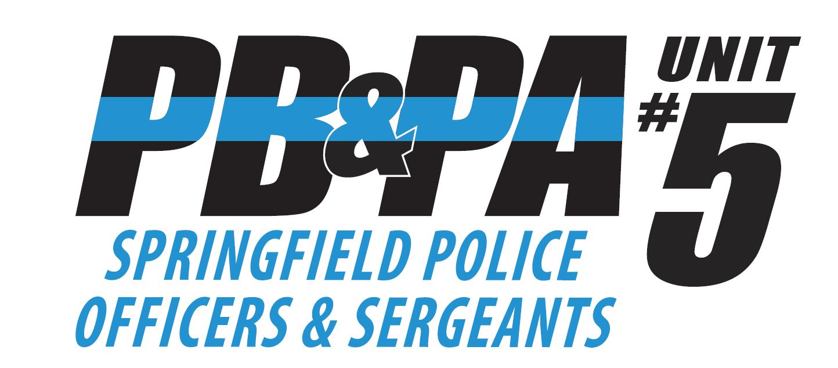

2023 STATE PB&PA GOLF TOURNAMENT REGISTRATION FORM
Golfers Names: Print Clearly
Team Captain: _____________________________________________________
Golfer #2:_________________________________________________________
Golfer #3:_________________________________________________________
Golfer #4:_________________________________________________________
Email Address for team captain: __________________________________
4 Person Best Shot Scramble July 11th, 2023 ($100 per person/$400 per team)
Circle preferred flight: Morning (7:30 am) OR Afternoon (1:00 pm)
Limited to 36 foursomes per flight. Assigned flights determined by the order registration forms are received and will not be accepted without payment. Confirmation of flight assignment will be emailed to team captain.
Deadline for Registration is June 30th, 2023
Return completed registration form and check payable to: PB&PA Unit #5
PB &PA Unit #5
P.O. Box 1441
Springfield, Il 62705
All questions can be directed to Tami Russell at pbpaunit5@gmail.com

